RESOLUTION NO.__________

RE: CERTIFICATE OF APPROPRIATENESS UNDER THE
PROVISIONS OF THE ACT OF THE PENNSYLVANIA
LEGISLATURE 1961, JUNE 13, P.L. 282 (53
SECTION 8004) AND BETHLEHEM ORDINANCE NO.
3952 AS AMENDED.

WHEREAS, it is proposed to secure a Certificate of Appropriateness for a sign at 313 E. Third Street.

NOW, THEREFORE, BE IT RESOLVED by the Council of the City of Bethlehem that a Certificate of Appropriateness is hereby granted for the work.

Sponsored by:

ADOPTED BY COUNCIL THIS DAY OF , 2015

President of Council

ATTEST:

City Clerk

HISTORIC CONSERVATION COMMISSION

CASE # 567 – It is proposed to secure a Certificate of Appropriateness for a sign at 313 E Third Street
OWNER/APPLICANT: Jeannie Agentis Revocable Living Trust/ Bill & Sue Dech

The Commission upon motion by Mr. Roeder seconded by Mr. Evans adopted the proposal that City Council issue a Certificate of Appropriateness for the proposed work described herein:
- The proposal to secure a Certificate of Appropriateness for a sign at 313 E Third Street was presented by Sue Dech.
- The new sign is located on the left side of the existing storefront. The sign is made of a metal box clad in stainless steel with cutout letters for the name of the restaurant. The sign is internally illuminated with variable color LED lights.
- The new sign is 3’ x 9’ x 1 ½” in size.
- The internally illuminated sign was approved because it was not a typical 6”-8” thick commercial box sign and it was similar to other custom-made internally illuminated signs approved in the historic district.
- The proposed motion was unanimously approved.

CU: cu
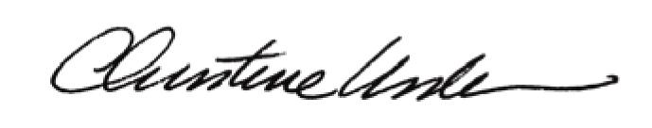

By:

Date of Meeting: September 21, 2015 Title: Historic Officer

